MAE 434w: Engineering Project Management and Design I

Paper 3:
Proposal for Pectus Excavatum Steel Bar Implant Sensor

Maureen Loughran
Christina Felarca
Adham Sobhy
Greg Ragosta

Date: 12/06/2012
Instructor: Dr. Bao

The Condition
Pectus Excavatum is a deformity of the anterior wall of the chest and of the rib cage in which the breastbone, also known as the sternum, concaves and results in a sunken chest wall that ranges in severity (Diseases & Conditions: Pectus Excavatum). It is more prevalent in preadolescent children, however there are some adults who also suffer from it. The direct cause of this abnormal development of the rib cage is unknown, because the majority of people with this condition have had it since birth or early infancy. However, one theory explains that if the ribs grow at a faster rate than the expansion of the heart and lungs, the sternum can sink inward. The expansion of the heart and lungs is one of the main contributors to the sternum being pushed outward, so it is crucial that it occurs at the same pace as rib growth. Another explanation could be that the cartilage holding the ribs to the breastbone developed abnormally, pushing the breastbone in. (Adult Pectus Excavatum)
Other than the deformity of the chest, pain and fatigue are also symptoms associated with pectus excavatum. Even though the chest pain that most patients experience is not severe or long lasting, their quality of life is being decreased and that makes it a concern. Shortness of breath can also occur, but it usually does not affect the patient during normal day-to-day activities. However, strenuous activity may cause the sternum to press on the heart, not allowing it to perform as efficiently as it should. As the child grows older and if proper measures are not taken to improve their condition, the depression can become more pronounced and cause these symptoms to worsen. (Adult Pectus Excavatum)

In this picture, one can clearly note the concave appearance of the sternum and the lower ribs.
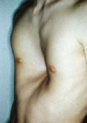
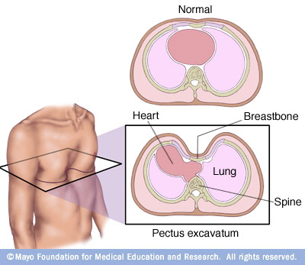
In this picture, one can clearly note the concave appearance of the sternum and the lower ribs.

The Solution
There is currently no known cure for pectus excavatum, but there are exercises that patients with mild cases can perform to minimize the symptoms of pain, fatigue, and appearance. These exercises target the back and chest muscles; aiming to straighten the back, pull the shoulders back, and expand the chest. In order for these exercises to be effective, they must be executed correctly and repeated daily. However, for more severe cases surgery is the best option for the patient. (Pectus Excavatum Exercise Program)
Before any operation takes place, various tests are performed to indicate whether a case is severe enough for surgery. After thoroughly completing a physical exam, submitting his/her health history record, and chest measurements, these factors will be evaluated and the patients whose condition is considered severe will then have multiple scans perform on them, such as a chest x-ray, pulmonary function study, an ECG (electrocardiogram, measures the activity of the heart), and a CT scan ("Diseases & Conditions: Pectus Excavatum").
Using the measurements from a CT scan, the Haller index, which is ratio of the distance of the inside ribcage over the shortest distance between the vertebrae and the sternum. In normal chests, the Haller index is about 2.5.Severe Pectus Excavatum is measured to be about 3.25 and can even reach to about 5.5 ("Pectus Excavatum").
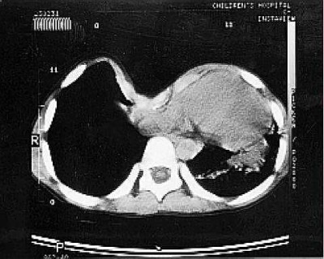
Chest CT of pectus excavatum
How to calculate the Haller index: HI= D2/D1
D1
D2

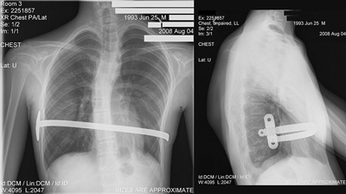
Today, the most commonly performed surgical treatment for correcting pectus excavatum is the Nuss Procedure. It was developed in 1987 by Donald Nuss, a pediatric surgeon from Children’s Hospital of the King’s Daughters, and is described as “minimally invasive” (Our Pediatric Surgeons). The Washington University School of Medicine’s website outlines the Nuss procedure as follows: “A bar is bent into the desired shape of the chest wall. A large surgical clamp is passed through one side of the chest, under the sternum and out the other side. The bar is pulled through using the clamp with the curve of the bar in the opposite direction. It then is flipped over and, in the process, bends the sternum outward, stretching the ribs as it does so.” The bars are left inside the patient on an average of two to three years. There is currently no way of knowing when the chest deformity has been completely reversed by the procedure. Surgeons depend on past cases and their own experience to make the final decision of removing the bar.
Front view of patient, after the Nuss procedure.
Side view of patient, after the Nuss procedure.
Cost Estimation for the Surgery
The cost for the Nuss procedure can vary, starting from $15,000-$30,000 ("Magnetic Mini-Mover Trial Study FAQ"). However, the price will depend on the amount of work needed for the correction and how much insurance will cover.
RFID
RFID, also known as Radio Frequency Identification (Tags), is a miniature device, which can wirelessly transfer data from a RFID reader. Generally, RFIDs are attached to assets in order to track their location, which can generally be seen in stores to prevent theft. RFID takes in a radio signal, and then transmits back out the stored information on the tag. So long as the radio signal can penetrate the RFID's surrounding environment, the tag can be read, which has distinct advantages over previous forms of asset management such as bar codes. There are three primary types of RFID, active, passive, and semi-passive, each has it's advantages and will be discussed below .
Active RFID chips are powered by a battery, thus they have a much farther range and can be reprogrammed and/or do basic logic without the aid of a RFID reader. Passive RFID chips are unpowered and are short ranged tags, which can not be reprogrammed, only programmed once, or reprogrammed by a RFID reader, but are very inexpensive. Passive tags are what are used in credit cards, driver’s licenses, wireless access/id cards and passports. Semi-Passive RFID uses a battery to power sensors and other parts of the chip, allowing for farther range and more data output via the radio . Such passive chips can automatically shut-off until they receive a signal from an RFID reader.
A specific type of semi-passive RFID was developed by Intel in 2009, which is entitled WISP or Wireless Identification and Sensing Platform, is entirely powered off of the incoming radio signal. This platform was designed to run a microcontroller and sensors, such as a strain gauge, and report out an RF signal that readers can not differentiate from standard passive RFIDs. WISPs have a capacitor onboard for storing power to be used by a low power 16-bit microcontroller, an accelerometer and thermometer, and have a 10ft range to collect RF signal as power .
Conclusion
In the installation of a metal bar in the Nuss Procedure, which is already an invasive procedure, the bar remains in the patient for a couple of years. In order to provide doctors with reliable information of when the bar is no longer under strain, and thus ready to remove, while remaining invisible to the patient, RFID technology combined with standard electronic strain gauges will be utilized so as to pass the data wirelessly through the body. IBM's WISP technology appears to be the ideal method of execution, especially as their blueprints and schematics are open sourced and available. Should WISP not be usable, an active RFID with kinetic power generation can be implemented. The final deciding factor, is the material of the bar, since if it is conductive the send/receive antenna of the RFID will have to be on the outside of the metal bar, as well as the electronics shielded. This project will advance this medical procedure to help provide better information and results for doctors and patients alike.

References
"Adult Pectus Excavatum." Cardiothoracic Surgery. Washington University of Medicine, n.d. Web. 2 Dec. 2012. <http://www.cardiothoracicsurgery.wustl.edu/patientcare/pectusexcavatum.asp>.
"Diseases & Conditions: Pectus Excavatum." Cleveland Clinic. The Cleveland Clinic Foundation, n.d. Web. 5 Dec. 2012. <http://my.clevelandclinic.org/disorders/pectus_excavatum/hic_pectus_excavatum.aspx>.
"Magnetic Mini-Mover Trial Study FAQ." Pediatric Surgery. The University of California, 2012. Web. 5 Dec. 2012.
"Our Pediatric Surgeons." Children's Hospital of the King's Daughter. Children's Hospital of the King's Daughter, n.d. Web. 2 Dec. 2012. <http://www.chkd.org/Services/Nussprocedure/Surgeons.aspx>.
"Pectus Excavatum." Seattle Children's Hospital Research Foundation. Seattle Children's Hospital, n.d. Web. 2 Dec. 2012. <http://www.seattlechildrens.org/medical-conditions/bone-joint-muscle-conditions/pectus-excavatum-symptoms/>.
"Pectus Excavatum." - Thoracic Diseases & Disorders at Columbia University Medical Center. Columbia University Medical Center, 2012. Web. 05 Dec. 2012.
"Pectus Excavatum Exercise Program." Children's Hospital of the King's Daughter. Children's Hospital of the King's Daughter, Feb. 2009. Web. 2 Dec. 2012. <http://www.chkd.org/HealthLibrary/Facts/Content.aspx?pageid=0400>.
"Radio Frequency Identification." Wikepedia. N.p., 2012. Web. 2 Dec. 2012. <http://en.wikipedia.org/wiki/Radio-frequency_identification>.
Roberti, Mark. "What Is a Semi-Passive RFID Tag?" RFID Journal (n.d.): n. pag. Web. 2 Dec. 2012. <http://www.rfidjournal.com/article/view/8117>.
"WISP: Wireless Identification and Sensing Platform." Intel Labs Seattle. Intel, 2010. Web. 2 Dec. 2012.

Responsibilities

Maureen and Christina split the task of researching the background information for pectus excavatum and creating an informative summary of the condition and the current treatment, the Nuss procedure. Greg took on the task of researching RFID technology and explaining the difference between active and passive RFID. Greg also concluded the paper and explained the group’s main concept for sensing if there is a force being applied to the bar. Adham was responsible for researching a few metals and discussing some of their material properties.

